CHINA CONSULTING ASSIGNMENT:
DATONG XINCHENG NEW MATERIALS
_____________________________

Presented to Julie Chesley, Ph.D of
The George L. Graziadio
School Of Business and Management
Pepperdine University
_________________________________
In Partial Fulfillment
of the Requirements of MSOD 620
Transorganization Systems and Strategies
_________________________________
by
Albert Yu, Brenda Stone, Jenn Cornelius, Kim Waldron, Lauren Dainko
April 24, 2017

Participation Agreement:
The Datong XinCheng New Materials consulting team confirms that all members – Albert, Brenda, Jenn, Kim, and Lauren - sufficiently contributed to this assignment, which included active participation in contributing ideas, discussing design rationale, reviewing materials and the writing of this paper. We are satisfied with the contributions of each member.

Introduction
Datong XinCheng New Materials (DXNM) is a graphite product manufacturer in Datong, China. According to a Worldscope March 2017 report, DXNM is “principally engaged in the research, manufacture, distribution and processing of special graphite” and its main products consist of graphite blocks, disks, crucibles and others. DXNM, with registered capital of 120 million yuan (approx. $17M USD) and production capacity of 34,000 tons, is one of the top three graphite enterprises in China (China Graphite Report 2017 - 2021) and was named by ResearchandMarkets.com as a major isostatic graphite production enterprise. DXNM is the founding member of Chinese industrial standards of carbon specialties and owns 42 patents (11 patents for invention and 31 patents for utility models). In addition to conventional graphite products, DXNM continues to invest in research and production of new products. On their website, DXNM states their goal is to not just provide products, but also to provide a complete solution including product design, tooling, fabrication and service for their customers to achieve their upmost satisfaction.
DXNM’s plant was established in 2007, and they now have more than 500 employees. In 2014, they became the only organization in Shanxi Province to be listed on the stock market. They export to countries including America, India, Japan, and Germany. Domestically, they were recently awarded the opportunity to provide products serving China’s high-speed railways. DXNM adheres to the principle of "quality first, service first, continuous improvement and innovation” to meet the needs of customers for management and "zero defect, zero complaints" as the quality objective. To perfect their service, DXNM aims to provide products with quality at a good value.
The point of contact for the consulting project is Ms. Qian Jingrong, (English name: Grace). Ms. Qian is an executive at DXNM responsible for marketing. Ms. Qian was also the point of contact for an engagement with the Sigma Prime Consulting group that took place between August and November of 2016. During that engagement, the Sigma Prime Consulting team aimed to create a space for authentic dialogue that could tackle many challenges within the organization due to recent changes. DXNM had implemented structural changes prior to the Sigma Prime intervention and that was the focus of their project: How to succeed in change. Ms. Qian noted that while the intervention was effective, very little was done to follow up on any of the ideas, commitments, and action items generated as a result of the intervention.
Contracting
When the consulting team first convened, we prioritized and engaged in team-building activities to better understand each other’s motivations and definitions of success for the project, as well as to develop trust in each other as it was apparent early on that not all of us would be available for every client interaction.
In preparation for contracting with the client, the team conducted a study on organizational context (see Appendix A), collected cultural entry data from Hofstede, Aperian Global, and Harvard Business Review, and connected with two members of the Sigma Prime Consulting team, Miriam Volle, team lead, and Rodney Slaughter.
Paul Wang, a Pepperdine MSOD Alumnus based in Beijing, was assigned as our client coordinator and Michael Fang, was assigned as our translator. Both Mr. Wang and Mr. Fang worked with DXNM last year and have provided invaluable input and translation support before, during, and after contracting calls. Usually just prior to the client calls, Mr. Wang has made himself available to speak with the team to touch-base and be on a common page.
Over the past month, the team held four calls with Ms. Qian, averaging about an hour each. Many challenges were discussed during the initial discovery call and throughout each contracting session with Ms. Qian. Ms. Qian reported low efficiency and low collaboration leading to lower than desirable production levels and efficiency. The reasoning for the unsatisfactory performance was not made clear, however communication seemed to be a significant factor that led to the lack of collaboration between workers and teams. Limited management capabilities, follow-through, and low levels of worker initiative and engagement were other areas of concern Ms. Qian also expressed. Ms. Qian said that it was important for DXNM to succeed in efficiently producing new technically challenging railway products. She hopes there is more coordination and collaboration with all departments and that they are committed to work together to fulfill assignments. The leaders of DXNM want to see people have individual initiative and efficiency and aspire to have these capabilities like Huawei, an innovation leader in China.
With the many challenges addressed in the initial discovery call it was necessary to go back to the client for clarification and further information in order to narrow the scope of this contracting assignment. After the team reviewed their understanding of the core issues Ms. Qian shared, the team presented a number of possible topics to focus on, one of them being communication. The lack of communication was a seemingly wide spanning issue which contributed to many of the other challenges DXNM was facing.
The Chairman of DXNM, Mr. Zhang, is an important figure in the company. His support will be vital in driving any intervention or messaging being introduced to the employees of DXNM. While Mr. Zhang has not been able to join any of the contracting and discovery calls, the team did seek to secure certain commitments for his participation in the intervention. We felt it critical for Mr. Zhang to be there at least at the beginning to introduce his desires, and to return at the end to emphasize the importance of work completed by the participants. These asks were conveyed through Ms. Qian.
Engagement Objectives
We confirmed the following problem statement with Ms. Qian: “Low efficiency and low collaboration are leading to lower than desirable production levels and efficiency. It is important for DXNM to succeed in efficiently producing technically challenging railway products.” To define the objective of this engagement, the team explored two over-riding questions. First, what are the underlying conditions for working efficiently and collaboratively, and what is the current state of these conditions at DXNM? Second, what can they learn and continue to do after we leave that is most relevant to their needs?
For the first question, we identified three underlying conditions for effective work: the ability to know when things have gone wrong, the ability to determine the cause or drivers for improvements (these can be skills issues, systems or equipment issues, management issues or a mixture), and the ability to effectively share information and translate that information into action.
For the second question, we were strongly influenced by the fact that we would not have access to information or personnel closest to the production process, as Ms. Qian, a marketing executive, discouraged access to manufacturing managers during the design phase. Without an ability to focus on any particular condition, we decided on a critical competency that would be beneficial across all conditions, which was communication. The purpose of the intervention will be to build effective communication and collaboration practices that lead to action and execution of business objectives and outcomes at DXNM.

The Intervention
To develop the agenda for the two-day intervention, we were guided by the following requests or advice that surfaced during our calls with Ms. Qian, Mr. Wang and Mr. Fang: 1) involve the Chairman - without his support there will be no change, 2) build from Sigma Prime’s work, 3) imparting knowledge is not enough, action is needed and 4) having members verbally report their commitments was effective as an outcome of the Sigma Prime project and will be expected again. We were keenly aware of cultural dynamics that the consulting team would need to be sensitive to: 1) The importance of not “losing face”, 2) people in lower hierarchy positions will not say “no” to higher levels, and 3) collaboration in China differs from US (e.g. doing things outside of what is asked can be seen as insubordination, roles aren’t clearly defined, etc.) (See Appendix B).
Based on our contracting conversations with Ms. Qian, the intended outcomes of the intervention are:
- Generate common aspiration for a communicative and collaborative workplace.
- Apply a communication framework that creates effective cross-departmental
communications.
- Ability to practice and implement concepts, tools, and processes.
- Commitment to take action toward achieving business objectives and outcomes.
In order to achieve those outcomes, we determined a set of grounding principles to guide the eventual design of the intervention:
- Provide a safe space for all participants to speak and be heard, regardless of their job rank.
- Utilize a combination of traditional and interactive teaching techniques.
- Design for real time knowledge-sharing & learning.
- Concepts, tools, and processes are simple to share and apply.
The following is a summary of the draft agenda, including possible design elements and the rationale behind those elements. We are still in process of finalizing our design intervention with further input from Ms. Qian and Mr. Fang.
Agenda Item | Design Element | Description/Rationale
DAY ONE (HALF DAY)
Welcome  Large group presentation | Chairman Zhang Opening Remarks  Introduction of Pepperdine Consulting Team  Introduction of all participants | Chairman’s sponsorship to establish credibility for this intervention and for the consulting team.  Create connection between consulting team and participants, build rapport
Welcome  Large group presentation | Connect to previous work – Ms. Qian or Team Lead | Build from Sigma Prime work
Check-In  Small group exercise and large group debrief | Generate aspirational storytelling through Dixit cards. “Why are we here and what do we want more of?” | Surface shared purpose from the group. Minimizes “losing face” by focusing on aspirational vs deficit.
Lecture + Practice  Large group presentation and small group activities | Communication Warm-Up exercise: The Sender-Receiver Illustration challenge | Simple exercise to demonstrate two outcomes: Sender and Receiver roles not static, and Communication involves not limited to using the right words.  Create comfortable learning space.
 | Lecture content: Communication Model based on SBAR, Listen/Reflect/Check for Understanding. To include Structural and Interpersonal elements. | Lecture format to create familiar academic environment, to establish credibility as experts
Credible (used in other large institutions, SBAR in hospitals, etc.), action/decision oriented, effective techniques when situation and solutions are unclear.

Communicating for action requires the following steps: Initiate Dialogue, State the Issue, Propose Action, Decide on Action, Execute the Action, Report Status, then the cycle repeats.

For each of these stages there are Structural supports for communication (for example, regular meetings, stated goals) and there are Interpersonal Skills. We will focus training on Interpersonal Skills and the dialogue that must occur between the Sender and Receiver in order to translate to action.

Outcome: communication rubrics for senders and receivers. Recognition of Structural components outside of interpersonal communication components.
Test for Knowledge/  Individual or small group exercise  Check-out & Close | Post-Test: Ask participants to re-create the model.  Self-rank strengths and opportunities | Outcome: Test for knowledge acquisition and build self-reflection.
DAY 2 (FULL DAY)
Check-In | [Check-in exercise TBD]  Prepare for more Practice  Revisit Purpose  Recap Day One  Set up for Skills Building Practices | Outcome: Create safe space for practice concepts introduced on day one. Building bridge to worksite relevance.
Experiential Learning  Small group exercise | Marshmallow Challenge - simulation of a building project | Simulate a building project with very loose specs, requiring collaboration and good communication for teamwork.  Outcome: Debrief to test for clarity of purpose, roles and responsibilities; effectiveness of communicating during changing scenarios.
Lecture + Practice  Large group presentation and small group exercises to apply learning | Skills Building on Results Oriented Communication tools.  Action and execution is best supported when committed actions are clear and accountable. There are three models that we can present:  RACI: A project management tool that identifies tasks and assigns who will be Responsible for completing the task, who is Accountable for its success, who must be Consulted, and who must be Informed.  Kanban: A project management tool that is a physical board clearly showing what is Waiting To Be Done, what is In Progress, and what is Done.  OKRs: A method to track goals and commitments requiring teams to clearly identify Objectives and the Key Results that lead to their achievement.  Reflect using tools and communication skills | Share workflow tools used by large companies (Microsoft, Google) that incorporate results of Communication and make accountability visible.  Outcome: Transfer knowledge to action and create connection to relevant daily work situations.
Optional “Fun” session to close, time permitting | May include a “Curious about the US” segment World Cafe-like segment. | This was an area of great curiosity per Sigma Prime and may be expected
Reflections, Check-out & Close | Participants discuss the biggest learnings of the day from the various exercises. Chairman will be present. | End of day survey  Chairman sponsorship
DAY 3 (HALF DAY)
Drawing key learnings & application | Revisit original intention from Day One.  Explore the “structural” opportunities that can also improve communication for better execution (ie better meetings) | Outcome: Connect the dots from the first two days and tying back to the realities of participants at their respective workplaces.
Making Commitments | If you were to apply these principles and tools what difference do you think it would make for your team? What are you willing to try? What would success look like?  Possible Accountability Mechanisms:  - Accountability buddies  - Reporting progress to leadership | Outcome: Participants are committed to applying learnings and have identified incentive or source of accountability to follow through.
Check-Out &  Close | Chairman Zhang closing remarks  Event Evaluation  Thanks You’s & acknowledgements

Evaluation Methodology
To evaluate efficacy of the intervention, we have identified the following measures to examine:
To Evaluate... | Method to Measure….
Retention of Information from Lectures | Pre- and Post-Test to test knowledge acquisition and retention. Eg. Before the session: How familiar are you with xxxx on scale of 1-5
Willingness & Desire to Apply Skills | Post-Test question. Eg. How comfortable are you with applying these skills with your team on a scale of 1-5. What is the likelihood that you will apply? What is the likelihood that your colleagues will apply?
Relevance to Business Needs | Post intervention survey using WeChat. Eg Would you recommend that your colleagues participate in this workshop, if it were to be offered again?  Track verbal commitments from team members  Repeat consultation with Pepperdine
Design & Delivery Effectiveness | Post Intervention survey using WeChat. Rate effectiveness of presenters, segments. Suggestions for improvements to future workshops. Name two things that made the biggest impression...

Roles and Responsibilities
Throughout our time together we have all taken on many different roles, jumping in when needed in order to help support the team and move us forward. During our first meeting one of our very first tasks as a team was to discuss roles and assign our team leader, which Brenda boldly took on, and as the team lead she has been the meeting facilitator, client contact person, and the spokesperson for our team. Following assigning our lead we discussed the other constant roles and responsibilities that we wanted for our team. Albert is our Steering Committee liaison and is constantly helping us move forward to ensure that we are prepared for our entrance into China, Lauren is in charge of taking notes and setting up Doodle’s for meeting times, and Jenn and Kim are responsible for creating our presentation and handouts. These are our assigned roles for when we meet however, we have all taken on multiple tasks when they come up each time we meet in order to help support the team.
Prior to our calls with the client we have had team meetings where we come up with our agenda, and the questions that we want to ask. We then have a rolling Google Doc where everyone can go in and add anything that has come up outside of our time together. We also have a separate WeChat during our client calls, so that when our team leader is contracting with the client the rest of us are able to include our thoughts and ask questions that the lead is then able to see and ask during those meetings. When it comes to planning anything, from design to cultural entry we all divvy up the roles and share the load so that everyone is able to contribute and have a hand in creating our intervention.
Conclusion
DXNM is graphite business who has grown rapidly in the last seven years, and is starting to see a plateau in their industry. Their past work with Pepperdine and the Sigma Prime consulting team helped them work with creating a dialogue in how to succeed during times of change. They did some great work with Sigma Prime, however they are still left wanting the know-how in taking action on the commitments they have made. Going into this consulting project we are putting focus on having meaningful and effective communication, and providing frameworks and strategies on how to take action following those conversations.
We plan on focusing our efforts on effective communication strategies and action plans during our two day session at DXNM. Our focus on Day 1 is to think about the desired future and then provide examples and details on methods and frameworks for inquiry and action, as well as provide space to practice those techniques. On Day 2, our full day with DXNM, we will revisit our purpose and then provide several communication application tools that can be used at the organization. We also plan on having an activity for the participants to practice using effective and clear communication. Our evaluation process is made up of pre and post surveys, as well as conversations with the participants to ensure understanding of the concepts being presented.

Appendix A: Organizational Context
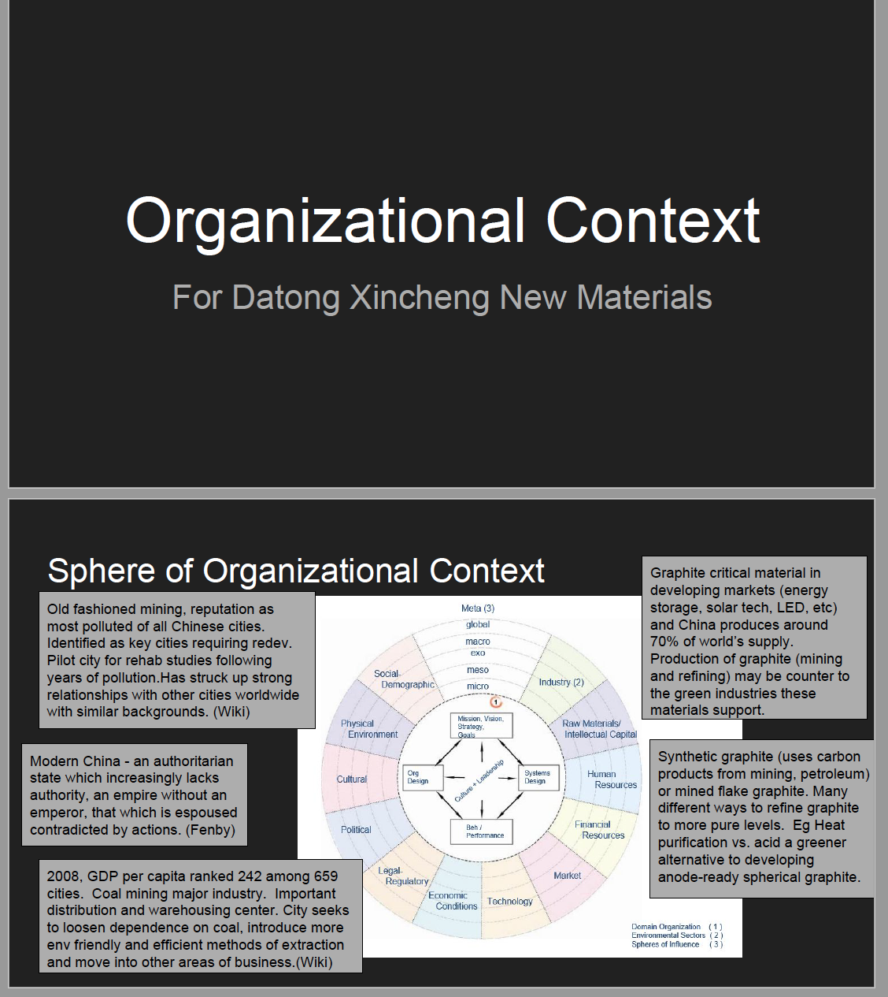

Appendix A: Organizational Context (cont’d)
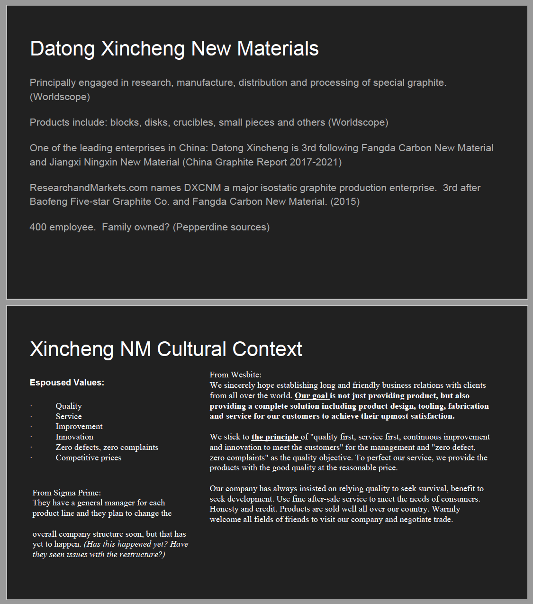

Appendix A: Organizational Context (cont’d)
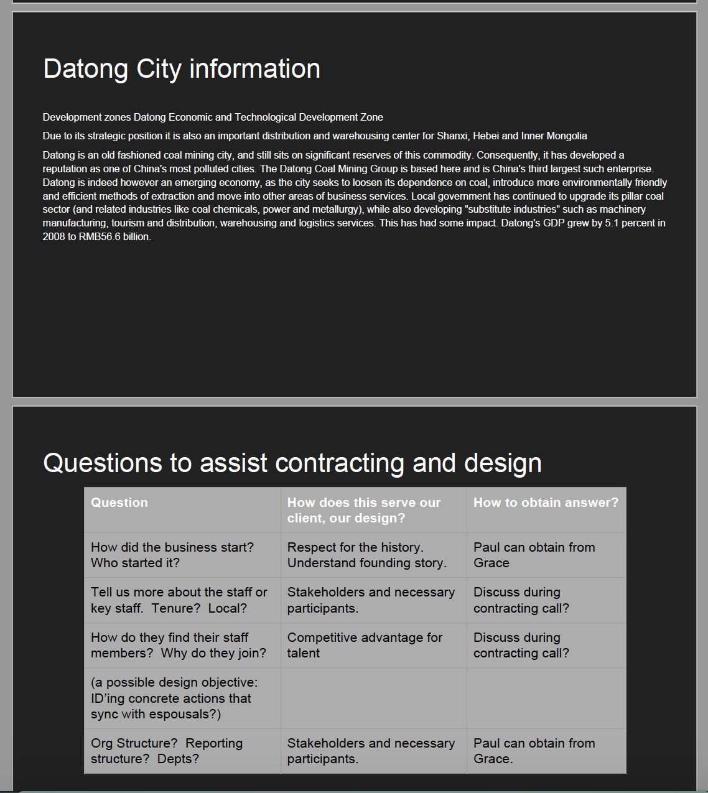

Appendix B: Collaboration in China vs. US
China
- Consensus-oriented
  - Focused on the group
  - Individual needs and desires are set aside for the good of the group
- Westerners can perceive it to be a lack of individual initiative. Doing something on one’s own is unusual
- Standing outside of the crowd has a negative connotation
- Do just what is asked, anything outside of that can be considered insubordination
  - Be sure to give clear, detailed, and complete instructions

(source: http://www.worldbusinessculture.com/Business-Teams-in-China.html)

US
- Task/Project-Oriented
- In teams the US tend to assign roles to the different members, and they each go off and complete their tasks and they come back together at a later date and share their findings
China
- People-Oriented
- Roles are not clearly defined
- Reach out to others when they encounter a problem and use the resources of others for help regardless of their role
  - They then find that they too are the recipients of such requests, which can create competition for time and resources for multiple projects

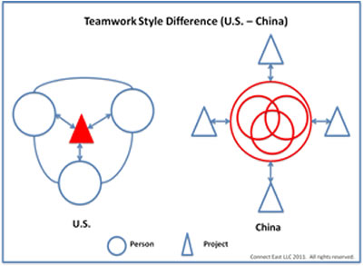

(source: http://www.connecteast.net/blog/managing-teamwork-in-us-.html)

China
- Society is hierarchical
  - The top makes the decisions
    - Mistrust puts limits on delegation
  - Mid-level managers have little power to make decisions of consequence
    - Main role is to pass orders from top to ensure execution

(source:https://www.forbes.com/sites/insead/2012/03/06/the-ten-principles-for-doing-business-in-china/#71be6edf1d82)

